Contents

Docker 2

Introduction 2

Solutions 3

Recommendation 21

Ansible 21

Introduction 21

Solutions 21

Recommendations 34

SDN Network 35

Introduction 35

Solutions 35

Recommendations 43

Network System Automation Report

# Docker

## Introduction

In my role as a Junior Consultant , I am focusing on deploying Docker to virtualize critical services such as web hosting and DNS management. This approach is designed to standardize application deployment across our diverse workstation environment, aiming to meet the case study requirement and By adopting Docker, Alpha can expect transform its IT infrastructure into a more adaptable and efficient system, capable of supporting our growing range of services and responding more dynamically to client demands.

## Solutions

The images on Figures 1,2,3 and 4 shows the initial setup of a Docker container on a root account followed by the installation of essential tools: curl, systemctl, and Apache2. This setup is crucial for Alpha Consultants as it lays the foundational technology for hosting and managing their web services for example in this case installing Apache2 fullfils Alpha's immediate need to stabilize and enhance their web hosting capabilities, directly meeting Requirement 2.1 for web site hosting and partially addressing Requirement 4, which calls for a configuration management system capable of managing and deploying configurations efficiently.

Figure 1 Running the docker container in root user



Figure 2 installing Curl

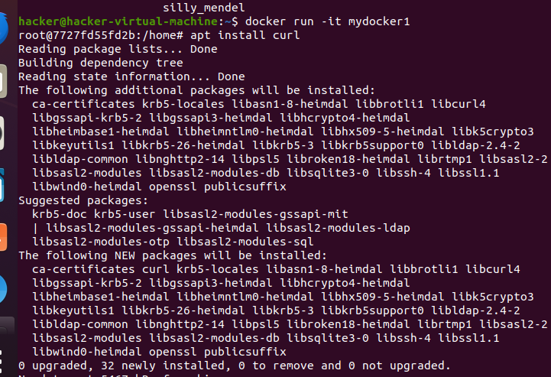

Figure 3 installing systemctl to start system services

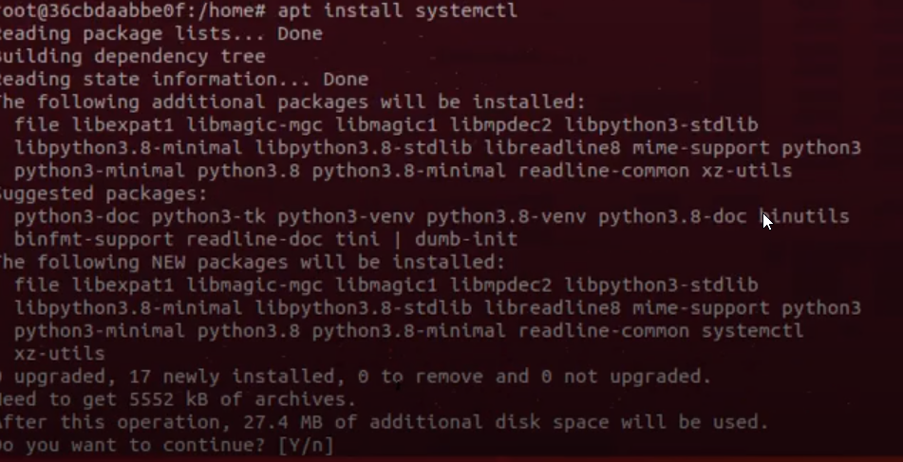

Figure 4 installing Apache2 as a web server

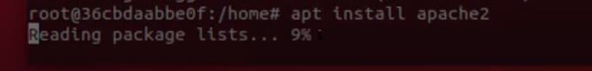

Figure 5 of the image displayed shows the curl command and output which is fetching a webpage from a local Apache web server, displaying the HTML source code. This indicates successful configuration and operation of a web server within a Docker container.This meets the Requirement 3, because it tells us that services must be hosted in virtual machines or containers.

Figure 5 Command to verify whether the webpage of Apache web server is setup

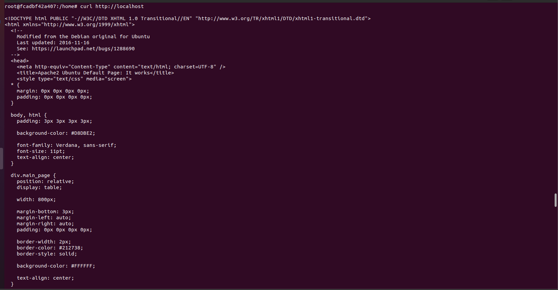

Images on Figure 6 demonstrate the commands user installation ,starting and verification of a MariaDB server within a Docker container. This is a crucial step towards establishing a robust backend for web services that Alpha Consultants is planning to host. Installing MariaDB, as shown in the images, is key to Alpha's objective of setting up a dynamic and flexible database service for their applications, which aligns with Requirement 2.1 for hosting their in-house PHP/MySQL web application.



Figure 6 Command used to install mariadb-server

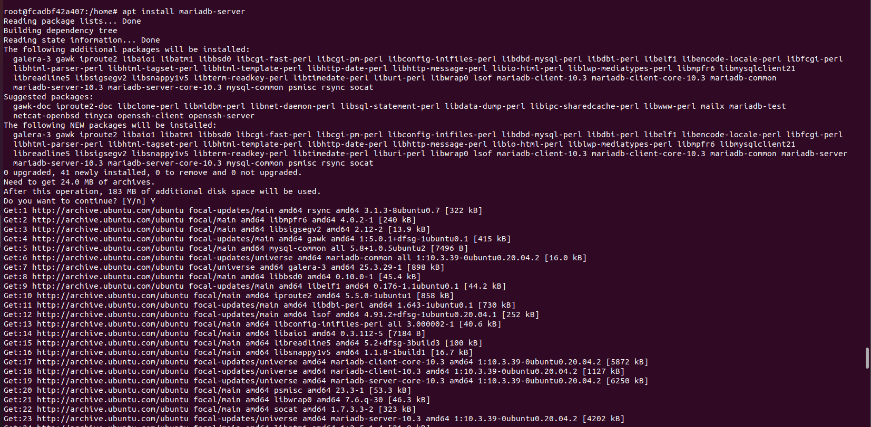

I have been having some issue with this command systemctl start mysql alternatively I had to use service mysql start

Figure 7 Starting the maria db server by using this command

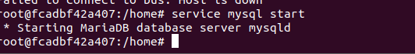

Figure 8 By this prompt we can create maria db database for Alpha to be ready to use the database server

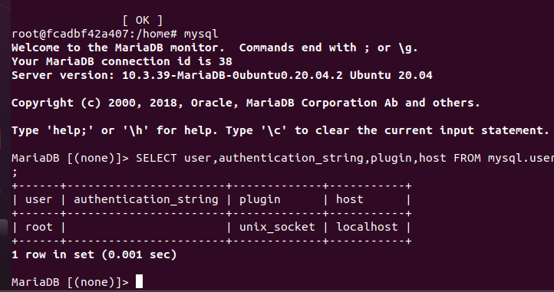



Figure 9 shows the installation of PHP and its associated modules, including the MySQL extension, on a server. this directly supports case study requirements as outlined in requirement 2.1 which required to host web site hosting in house of an in house PHP/MySQL application

Figure 9 installing PHP on the server container

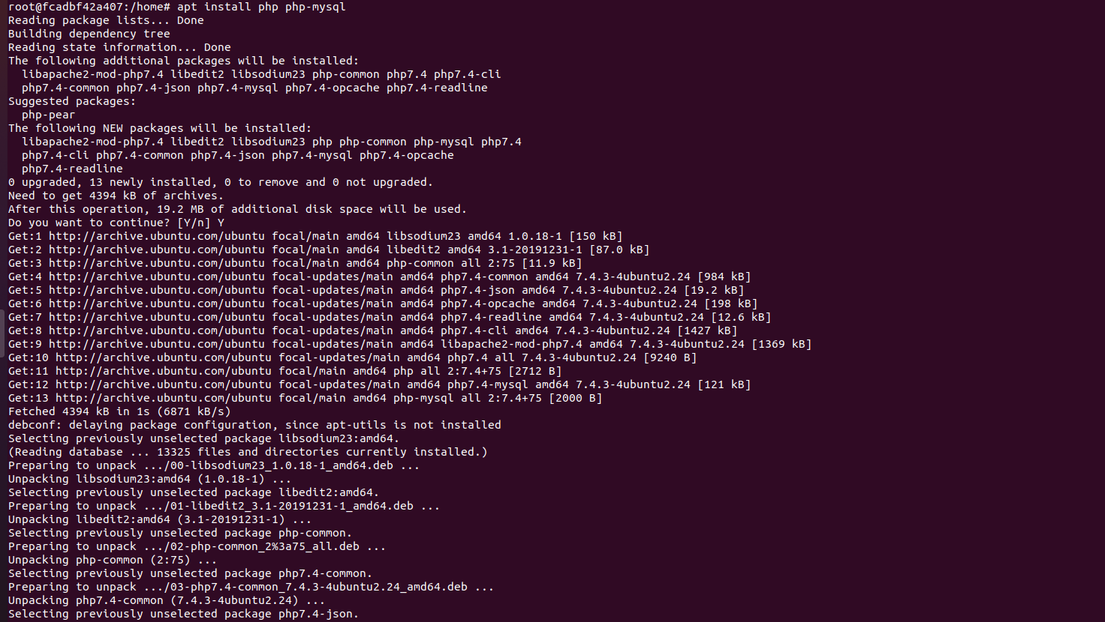

Both images illustrate the configuration steps of PHP on a Server container. The first screenshot shows a directory listing within /etc/apache2, highlighting important configuration directories and files such as sites-enabled where virtual host files are stored. The second on Figure 11 shows a command-line sequence entering the sites-enabled directory and opening the 000-default.conf file with Nano, a command-line text editor, to modify or verify web server settings.

Figure 10 changing directory

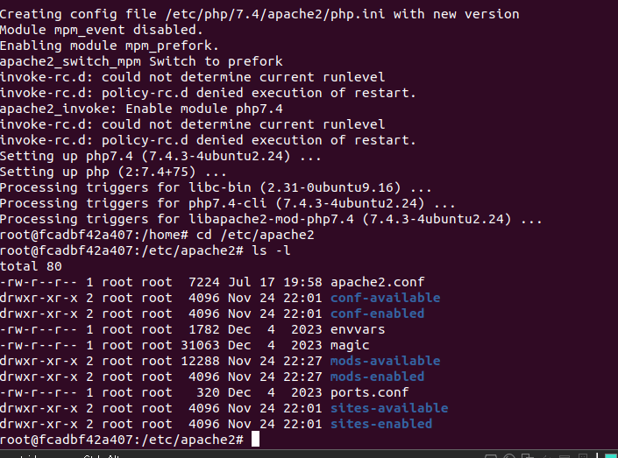

Figure 11 sites-enabled directory have been to used to create a nano text file

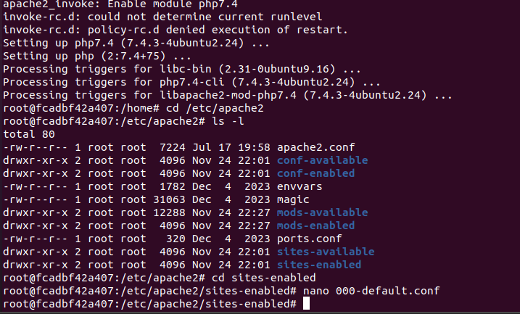

The images on Figure 12,13 & 14 depicts the configuration of an PHP web server in a Docker environment, focusing on modifying the 000-default.conf to set the document root and directory index for PHP processing, and creating a basic index.php file displaying PHP configurations. This setup aligns with Alpha Consultants requirement 2.1, aimed at hosting a PHP/MySQL application efficiently. By configuring the Apache server and verifying PHP functionality through phpinfo(), Alpha can ensure that their web services are correctly set up.

Figure 12 Modifying directory index file for PHP web server

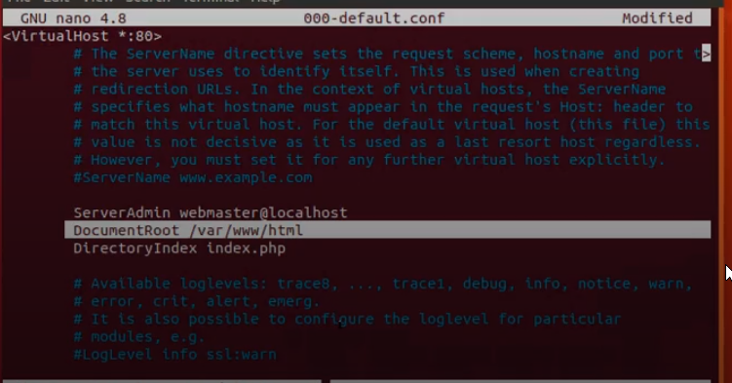

Figure 13 Used this command Creating a basic index Php file for nano text editor



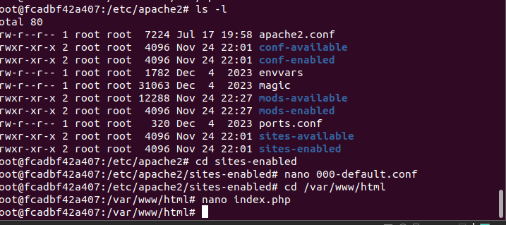



Figure 14 Then in the nano file editor we use this prompt to create a basic php webpage

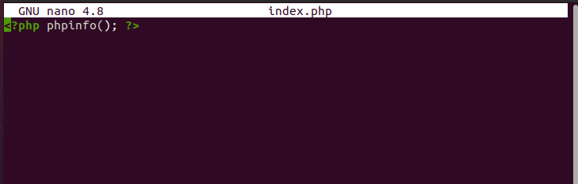



In Figure 15, we see the process of restarting the Apache2 web server and verifying the server's IP address, which is essential for ensuring that the web service is active and accessible on the network. This figure 15,16 and 17 aligns with requirements 2.1, which focuses on robust web hosting infrastructure for Alpha's in-house PHP/MySQL applications. Figure 16 illustrates using the Lynx command web browser allows to access the web server using the server's IP address. This step is significant because it demonstrates the operational status of the web server, confirming that it can serve web pages as expected. The last figure, displaying the PHP information page through Lynx, is crucial for verifying the successful integration and operation of PHP on the Apache web server within the Docker environment. This verification process is integral to ensuring that the server is correctly configured to handle dynamic content, which is particularly important for hosting Alpha's in-house PHP/MySQL applications.

Figure 15 Need to restart the apache2 web server and check the ip address used

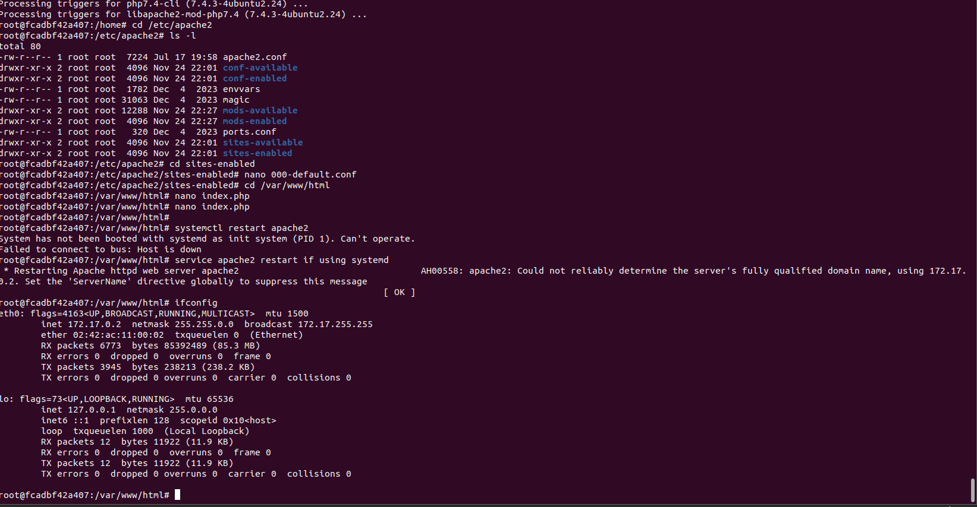

Figure 16 Used this command to start the text web based browser

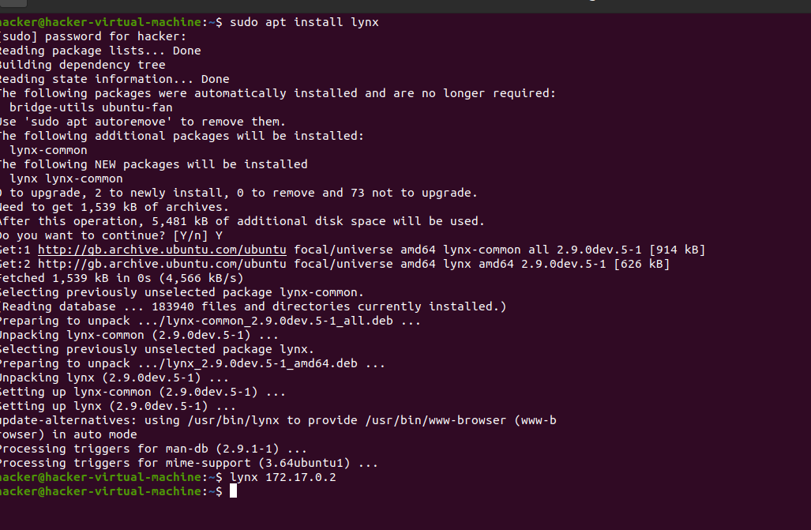

Figure 17 Text web based browser shown to check whether the website is working

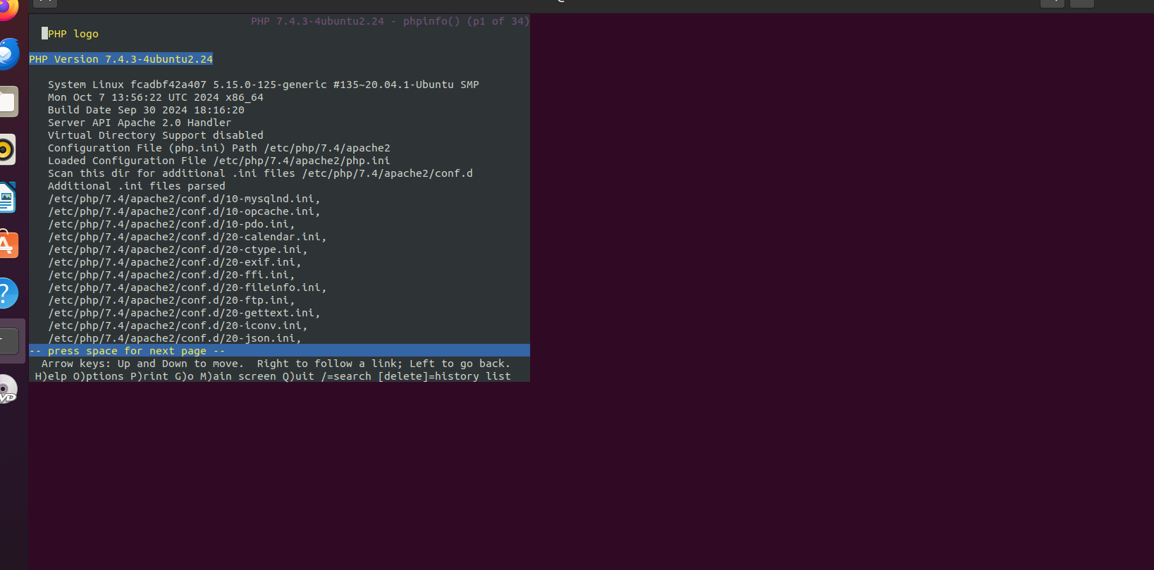

Figure 18 shows the successful display of the PHP configuration page on an php web server within a Docker container. This page confirms that PHP is correctly installed and configured, as evidenced by the detailed system and PHP configuration information presented. This step is pivotal for Alpha Consultants, meeting Requirement 2.1 of their case study, which calls for robust web hosting capabilities for an in-house PHP/MySQL application.

Figure 18 Images shows the successful execution have been made to display the php webpage

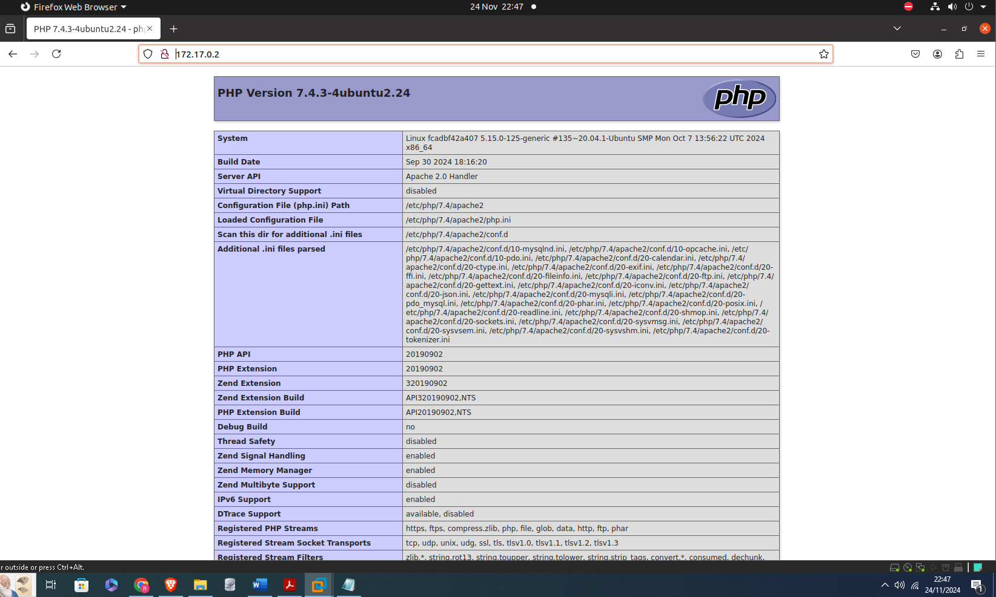

Configuring DNS server for Alpha

The image shows the installation process of BIND9 and associated utilities on a Linux server, aimed at setting up a DNS server. This step is crucial for Alpha Consultants as it directly relates to Requirement 2.2 of their case study. Requirement 2.2 specifies the need for a service that translates host and domain names to IP addresses, a fundamental function provided by DNS servers.

Figure 19 installing bind using this command for the DNS server

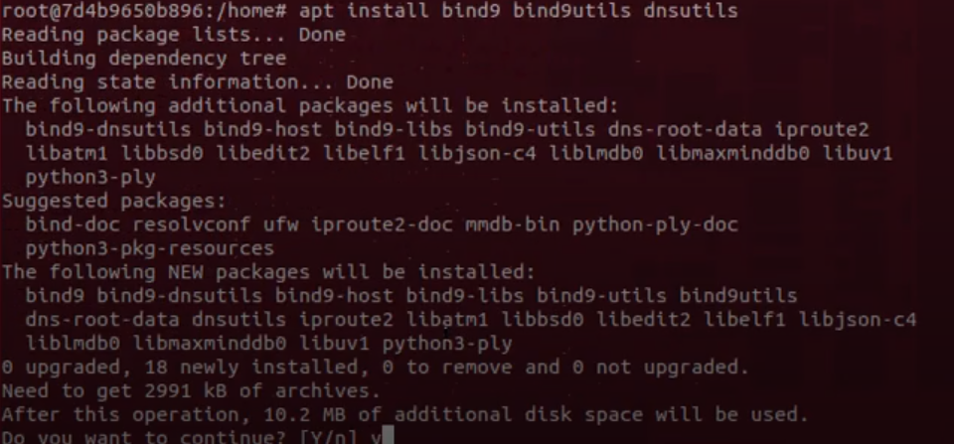

The image depicts the directory listing of BIND (Berkeley Internet Name Domain) configuration files within a Linux environment, essential for setting up a DNS server. This step includes navigating through various DNS configuration files such as named.conf, named.conf.local, and named.conf.options, which are crucial for defining the behavior of the DNS server, its zones, and additional options that manage how the DNS responds to queries. This setup process is critical for Alpha Consultants as outlined in Requirement 2.2 of their case study, which specifies the need to implement a service that translates host and domain names to IP addresses efficiently. By configuring BIND on their systems, Alpha ensures robust DNS management that supports their network infrastructure

Figure 20 checking and creating necessary directories for bind

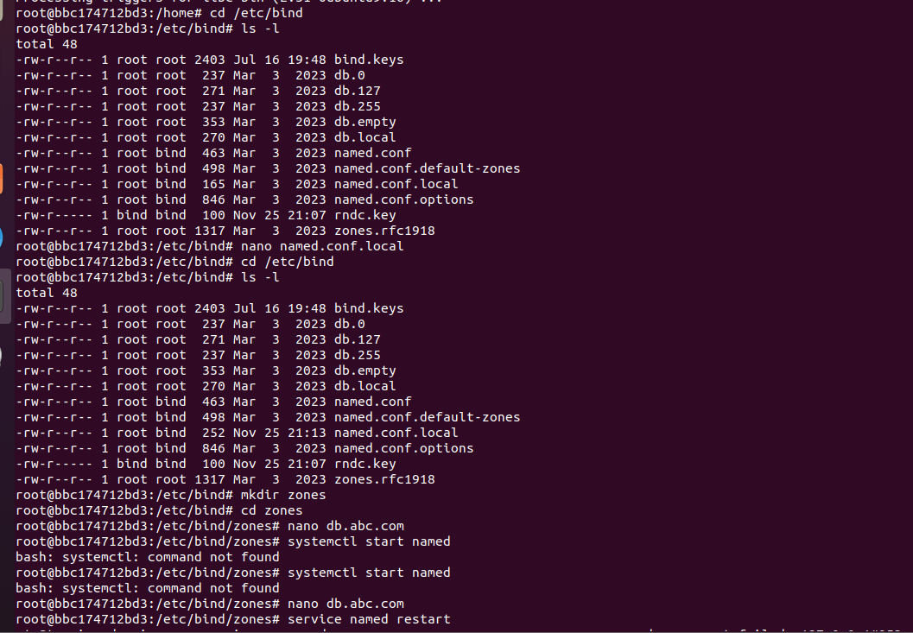

Figure 21 of the image shows the editing process of the named.conf.local configuration file within a DNS server setup on BIND in a Docker environment. This step is part of configuring a domain, "abac.com," which partially represents case study requirement 2.2 internal or test domain for their DNS server which necessitates a DNS service that resolves domain names to IP addresses.

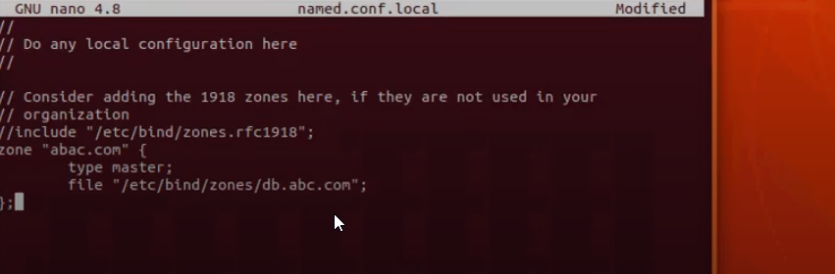

Configuring forwards zones

For demonstration purpose the image illustrate configuring a BIND DNS server within a Docker container, an essential task for managing network services. In the first image, the named.conf.local file is being edited to define the DNS zone for "abc.com," specifying "db.abc.com" as the zone file, crucial for resolving domain names within Alpha's network. This configuration supports case study Requirement 2.2 by establishing a DNS service that translates domain names into IP addresses. Figure 22 details the DNS zone file setup in "db.abc.com," showcasing the DNS records for internal hosts, which aligns with the requirement to maintain an efficient internal DNS system for Alpha's operational needs. The final image, showing the command to start the DNS service, confirms the practical application of the configuration, ensuring the apache2 server is operational

Figure 22 Creating nano text file for in this case abc.com within the directory

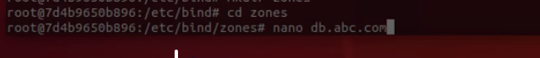

Figure 23 editing the abc.com file in nano text editor

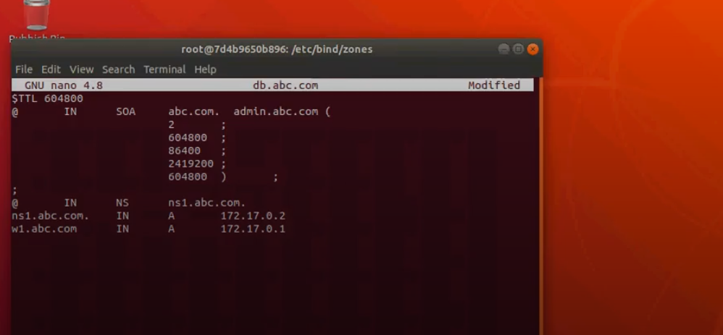

Figure 24 Starting the apache2 server



Making the dns server

The images on figure 25 ,26 and 27 details the steps taken to configure DNS settings for a Docker-based BIND server tailored for Alpha Consultants, following their specific requirements. In the first image, we see modifications to the resolv.conf file, setting nameserver and search directives to prioritize DNS resolution via the BIND server, crucial for network operations in accordance with Requirement 2.2. This ensures all domain name queries within Alpha are routed correctly, enhancing network efficiency. the successful execution on the figure mentioned nslookup command against the configured DNS server within the Docker container, confirming that the DNS service is effectively translating the domain name for example :ns1.abc.com to its corresponding IP address 172.17.0.2. This step demonstrates the operational readiness of the DNS server, ensuring that it is correctly handling name resolution requests, which is fundamental for maintaining network connectivity and service availability within Alpha Consultants.

Figure 25 Command to create a nano text file for configuration of DNS

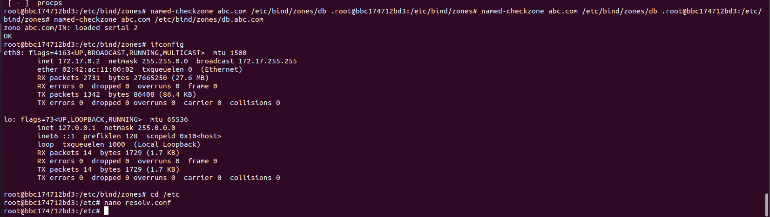

Figure 26 Editing the resolv.conf file

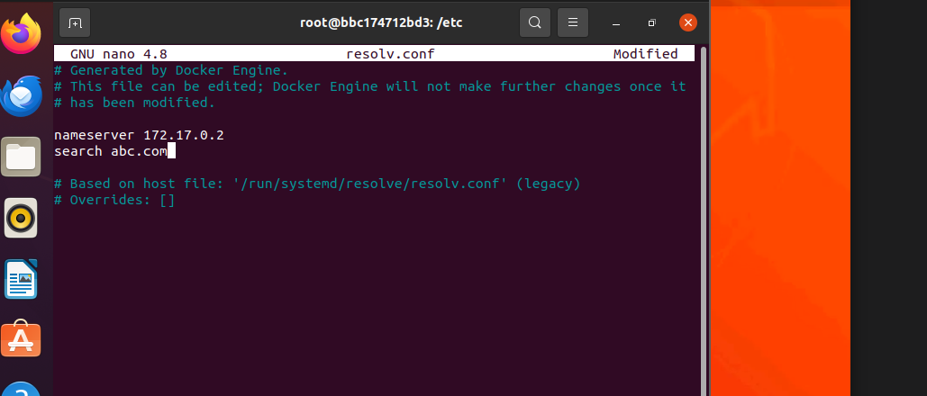

Figure 27 nslookup command used to check successful execution for the website address

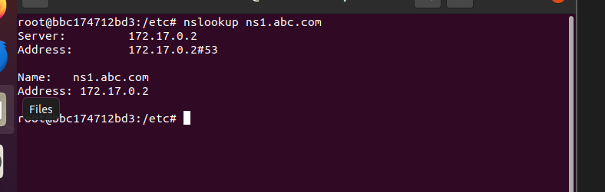

The images on Figure 28 ,29 and 30 showcase the setup and configuration of a BIND DNS server within a Docker container for Alpha Consultants. The first step was needed to create a nano file for and then on Figure 29 Editing the named.conf.local file establishes a DNS zone for "abc.com," directing it to use the db.abc.com zone file. This configuration aligns with Alpha's Requirement 2.2 to provide reliable DNS services, enabling effective translation of domain names to IP addresses. The detailed DNS records, including host mappings and server settings, ensure Alpha's network efficiently handles name resolutions. The process on Figure 30 concludes with the activation of these settings via the systemctl restart named command, confirming the DNS server's operational readiness to support Alpha's network requirements.

Figure 28 creating a nano file

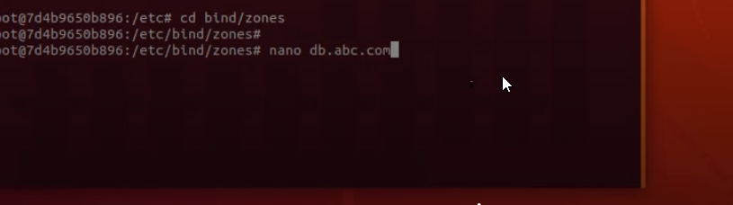

Figure 29 editing and modifying the nano file

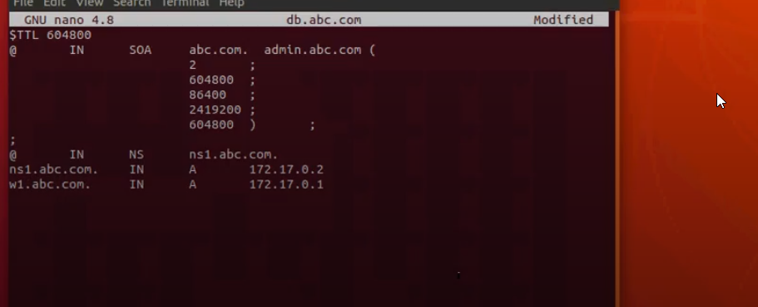

Figure 30 nslookup command used to check the website is working correctly

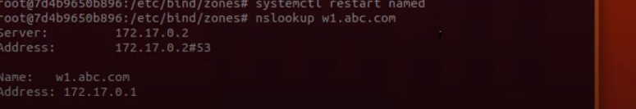

the images display the configuration of a BIND DNS server for "abc.com" within a Docker container, demonstrating a crucial network service setup for Alpha Consultants. The first image shows the DNS zone for "abc.com" in the named.conf.local file, pointing to the zone file "db.abc.com." This setup ensures domain names within Alpha's network are correctly resolved to IP addresses, meeting Requirement 2.2 of the case study, which emphasizes the need for efficient DNS management to support internal and external network operations.

The second image from nslookup command confirms the DNS server's functionality, showing successful resolution of the domain "[abc.com](http://www.abc.com)" to its designated IP address. This step verifies the operational DNS system, crucial for maintaining Alpha's network reliability and efficiency, thus directly supporting the case study's requirement for robust and effective DNS services in managing network traffic and resource access.

Figure 31 editing the nano file

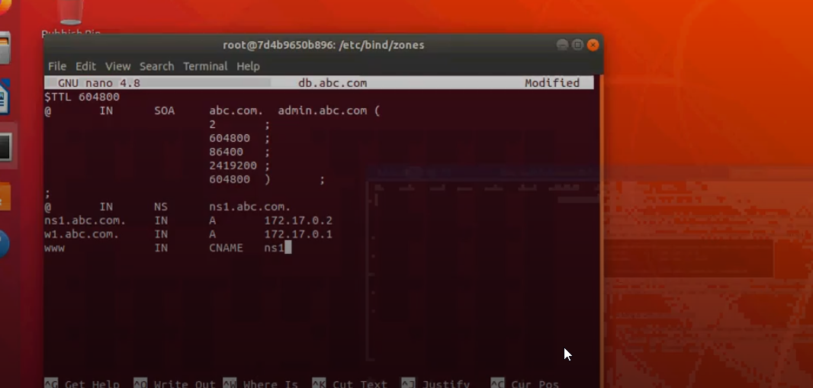

Figure 32 Sucessful execution of the domain abc.com

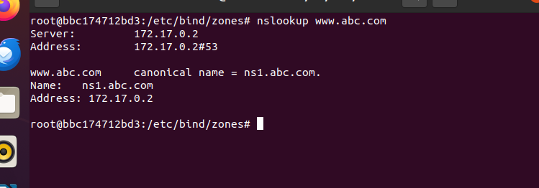

The images collectively on demonstrate the successful configuration and operation of a BIND DNS server for Alpha Consultants, tailored within a Docker environment to manage domain name resolution efficiently. The setup of the resolv.conf guides local DNS queries to the newly configured server, a critical step in verifying the DNS server's functionality with nslookup commands that confirm its ability to resolve internal domain names correctly. This robust DNS setup aligns with Alpha's specific case study requirement to ensure that their network infrastructure supports robust service delivery by reliably translating domain names into IP addresses. Furthermore, the final image displaying successful web page access through the configured DNS confirms the operational effectiveness of the server, showcasing how it integrates with other network services to facilitate seamless web content delivery. This end-to-end configuration underlines Alpha's objective in the case study to maintain an efficient internal DNS system, enhancing overall network management and operational reliability.

Figure 33 editing the resolv.conf file to configure domain

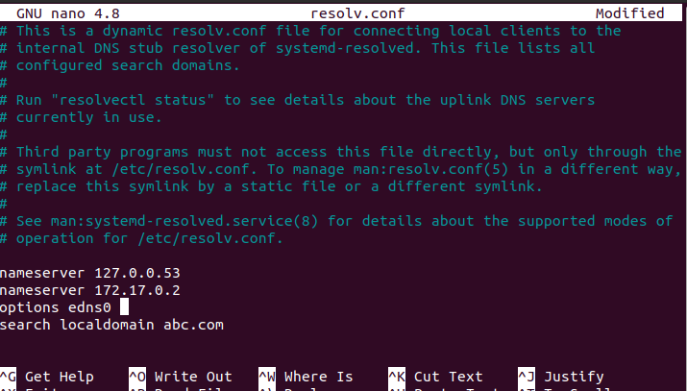

Figure 34 command used to confirm and check the web domain

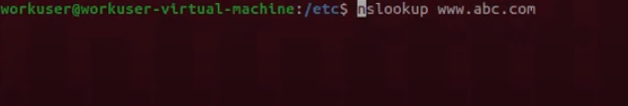

Figure 35 shows the Apache2 basic webpage is working after dns configuration

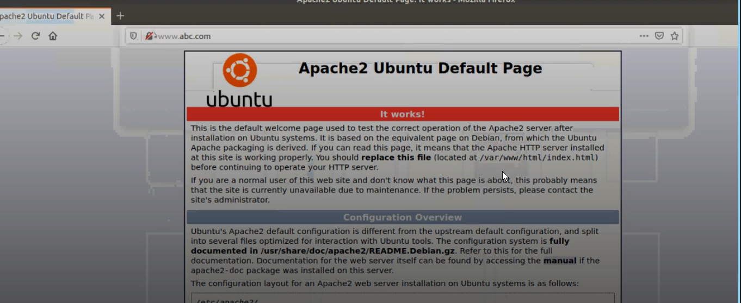

Reverse lookup

The images demonstrate the configuration of a reverse DNS zone within a Docker environment, a critical step for managing network services at Alpha Consultants. By editing the named.conf.local file is crucial for the DNS system to resolve IP addresses back to domain names, ensuring robust network management. The zone data file (db.172.17) in figure 1 includes PTR records that link IP addresses to specific domain names like ns1.abc.com and w1.abc.com, confirming the DNS setup's functionality. The process is then validated as shown in Figure 2 through the restart of the DNS service and subsequently nslookup command tests in Figure 3, verifies that the reverse DNS resolutions are operational. This efficient DNS management aligns with Requirement 2.2 of the case study, emphasizing the importance of reliable network services within Alpha’s infrastructure

Figure 1 editing db file in nano editor for reverse lookup zone

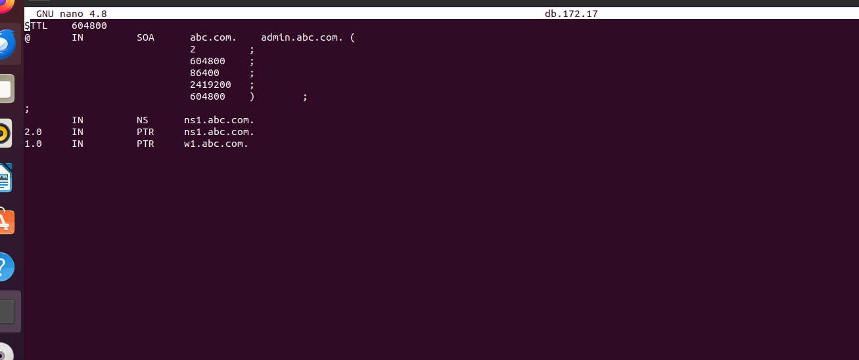

Figure 2 Need to verify whether this ip address is working correctly

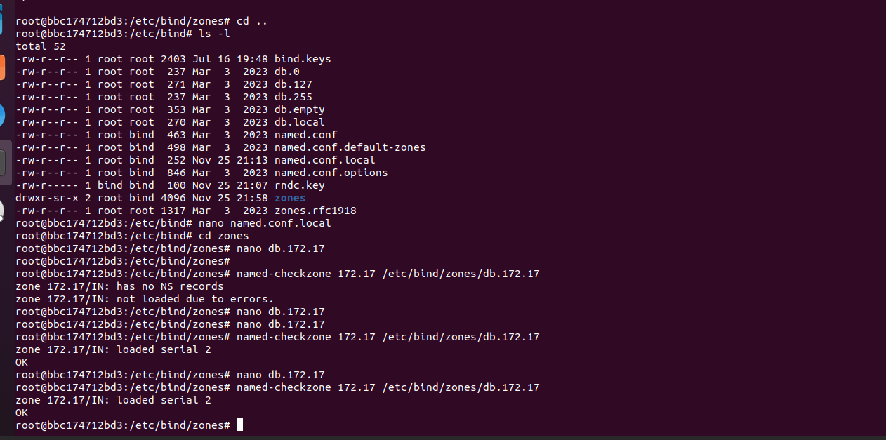

Figure 3 Need to restart and check whether the and reverse zone is working correctly

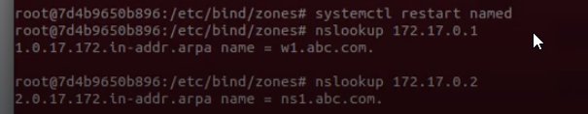

Figure 4 and 4.1 . Initially, I encountered issues while configuring the DNS records in a nano text editor, I had to specifically resolve the issue by adding a dot in the end like this : w1.abc.com. So To address this, I modified the DNS zone file w1.abc.com.By adjusting this issue and fixing it I had to run the nslookup again to check its functionality so that’s why meticulously checking the syntax and references within the file, which is crucial because (www.linkedin.com, n.d.)DNS configuration is sensitive to errors and requires precise syntax to function correctly. (www.linkedin.com, n.d.)

Figure 4 Error occur while editing nano file

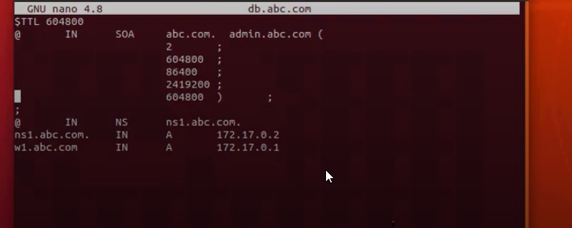

Figure 4.1 error issue while running the webpage domain

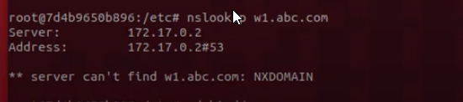

## Recommendation

 (Kumari, 2022)Docker enables the automation of network device configurations, ensuring consistency and reducing human errors. This is particularly beneficial for configuring Cisco routers, as it streamlines the deployment of network changes.  (Kumari, 2022) (Kumari, 2022)Setting up Docker Compose can provide better management and visualization of automation tasks. (Kumari, 2022) This setup allows Alpha to monitor automation jobs, manage inventories, and control access with a user-friendly interface, thereby improving operational efficiency.

# Ansible

## Introduction

As part of our ongoing effort to enhance operational efficiency and reliability, Alpha Consultants is integrating Ansible into our systems management framework. This strategic decision is driven by the need to automate and standardize configurations across our extensive network of servers and devices, particularly as we scale our services to meet increasing client demands. Ansible's robust automation capabilities will allow us to deploy and manage applications more swiftly and consistently, ensuring high availability and performance. This initiative directly supports our objective to optimize network operations and reduce the time and cost associated with manual configurations, thereby improving service delivery and client satisfactory.

## Solutions

Using Ansible to Configure a Cisco Router

Figure 1 illustrates the addition of a Cisco 7200 series router within the GNS3 network simulation environment. This practical simulation work is vital for Alpha Consultants as it allows for extensive pre-deployment testing and configuration of network protocols in a risk-free environment. By using GNS3 to simulate the router, Alpha can optimize network routes, test security settings, and adjust bandwidth allocations to ensure robust performance under varying operational scenarios. **Requirement 4.2** from the case study involves configuring and managing Cisco routers and switches. The simulation directly aids in pre-testing the configurations, reducing potential downtime and performance issues in Alpha's real network setup, thereby aligning with Alpha's goals of enhanced network resilience and configuration reliability.

**Figure 1**

Add 7200 series router

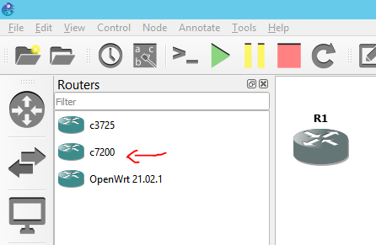

In Figure 2, we observe the setup of Ethernet switches within the GNS3 environment. Selecting and configuring switches in a simulation platform like GNS3 enables Alpha to validate switch performance and integration with network infrastructure. This step is crucial for ensuring that new or modified configurations work as intended before they are implemented in the live environment. **Requirement 8**: As Alpha's data center requires switches to be managed via a software-defined networking (SDN) controller, testing these switches in a simulated environment ensures compatibility and functionality with SDN controllers. This pre-validation is critical for seamless SDN integration and effective network management.

Figure 2 Make sure the ethernet switch is connected as shown

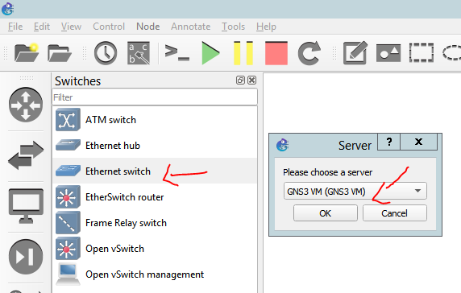

Figure 3 The VM and server light should be green

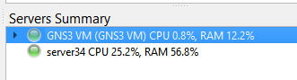

**Figure 4** showcases the configuration of end devices, particularly focusing on network automation tools within GNS3. This simulation is used to test network automation scripts and deployment strategies in a controlled setting, which is critical for ensuring that network operations can be automated reliably and efficiently across Alpha’s infrastructure. **Requirements 3 and 5** involve the virtualization of services and the deployment of in-house applications across network hosts. Testing these applications and services in a simulated environment ensures they are robust, reliable, and ready for seamless integration and deployment, supporting Alpha’s objectives of operational efficiency and technological advancement.

**Figure 4** Add a network automation

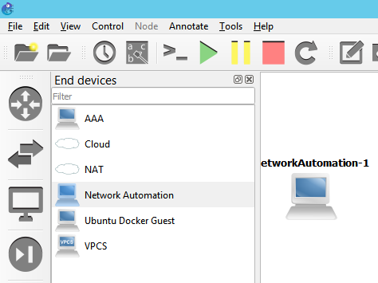

**Figure 5** depicts a basic GNS3 network topology with a computer, switch, and router. This test setup enables network administrators to simulate and refine network automation tasks in a controlled environment. For Alpha Consultants, this simulation is essential for optimizing ethernet connections between switches and routers before deploying them in a live environment. This aligns with Alpha's requirements **4.2 and 8** to maintain resilient network infrastructure and efficiently manage their data center switches and routers. Finally in **Figure 6** depicts the "Confirm Start All" prompt in GNS3, which is a final check before all simulated network devices are activated within the environment. This step ensures that all elements of the simulation are ready to run . This procedural step is vital for Alpha as it ensures that all network devices in the simulation—routers, switches, and end devices are functioning and interconnected correctly before any tests are performed. It's a safeguard that helps prevent time-consuming troubleshooting later and ensures that the network configurations tested can handle the expected loads and tasks. This practice is essential to fulfilling the case study’s requirements for network resilience and reliability (Requirements 10.2 and 10.3) by allowing Alpha to manage and correct configurations for optimal network performance.

**Figure 5** Add an ethernet connection to switch and router

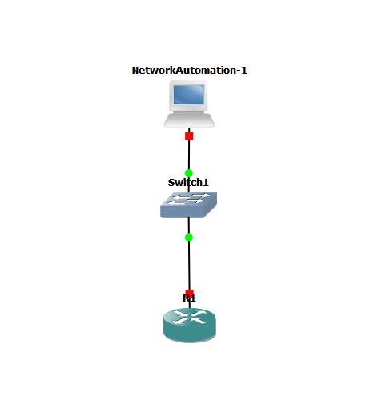

**Figure 6** We need to start all objects

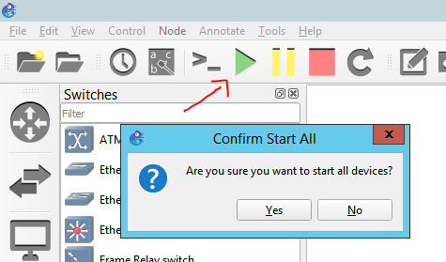

**Figure 7** illustrates the configuration of a temporary IP address for a network automation device within a GNS3 simulation. This setup is critical for Alpha Consultants as it enables the testing of network modifications in a controlled environment before implementing them in the production network. This directly supports Alpha's objective of improving network reliability and adaptability, particularly their requirements 5 and 10.2, which emphasize the need for efficient network configuration management and the ability to dynamically adapt to changing network demands

**Figure 7** Add temporary ip address to the network automation

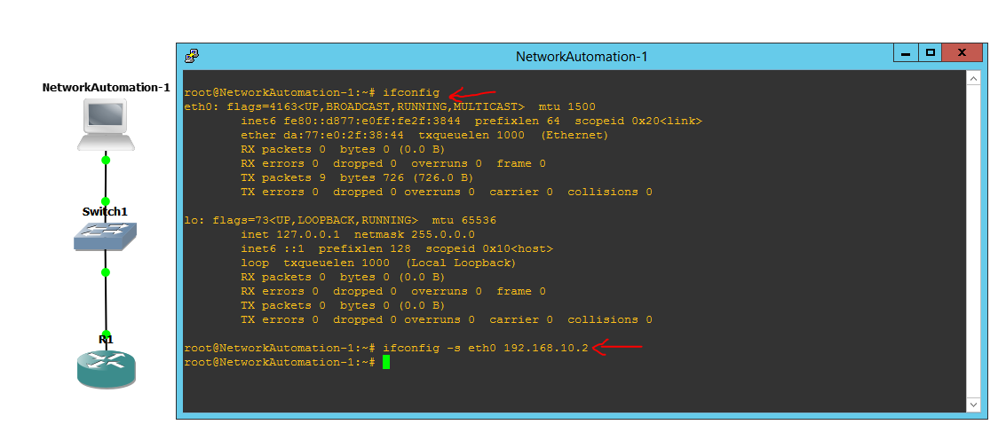

**Figure 8** illustrates the verification of the network connectivity by confirming the IP address on "NetworkAutomation-1." This step is essential to ensure that the device not only holds the assigned IP but is also capable of participating in the network as expected. Such verification is vital for Alpha Consultants as it ensures that any network component added or configured within their infrastructure is fully operational and meets the intended connectivity criteria. This contributes to the overall network reliability, aligning with Alpha's case study requirements to manage and monitor network efficiency and resilience, as stated in requirements 10.2 and 10.3.

**Figure 8** Confirm if the network automation have an Ip address

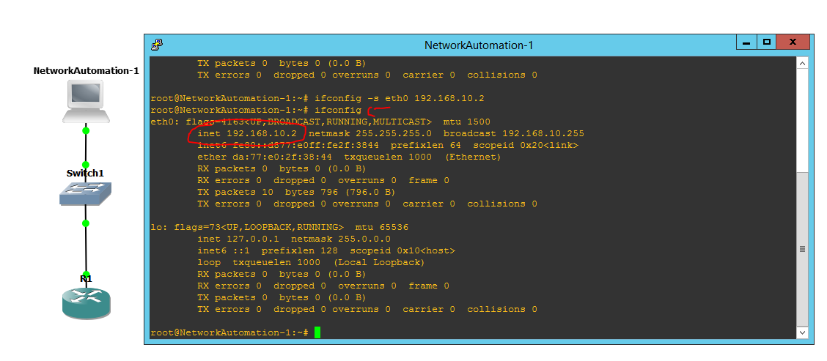

Image in **Figure 9** exemplifies a fundamental configuration task performed on a Cisco router within a network simulation environment, highlighting the process of assigning an IP address to an interface (FastEthernet0/0) and activating it with the command "no shutdown". This action is crucial for ensuring the router's interface is prepared to handle network traffic, a basic yet vital requirement for robust network operations. the image is directly tied to Alpha's broader network management goals. It addresses Requirement 4.2 of their case study, which calls for efficient management of Cisco routers and switches, ensuring that all devices are properly set up to communicate and route data effectively. Additionally, this task supports Requirement 10.3 by confirming that network traffic is routed correctly, enhancing the reliability and performance of the network system.

**Figure 9** Configure the Router IP address subnet mask and activating the interface no shut fa0 0

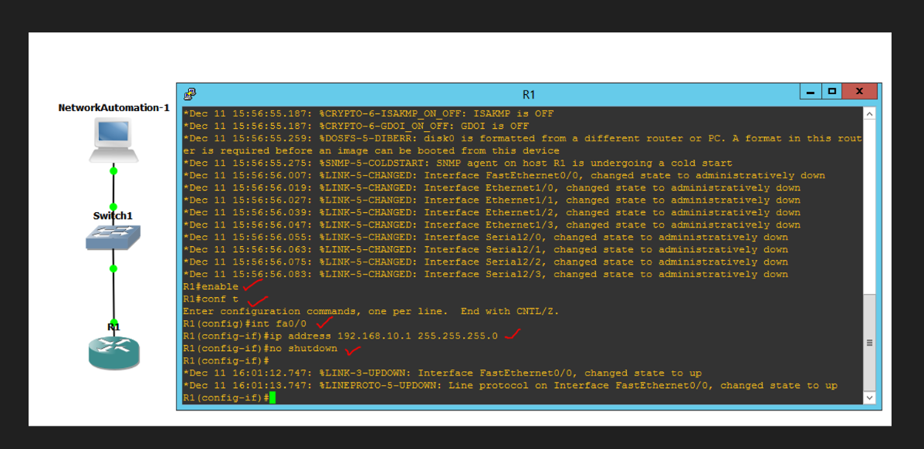

**Configure Ip address and SSH on the router**

Figure 11 illustrates the crucial process of configuring SSH settings on a Cisco router to secure network devices at Alpha Consultants. This procedure is vital for enhancing network communication security, aligning with Alpha's case study requirements, specifically Requirement 4.2 (managing Cisco routers and switches). Although Requirement 6 does not explicitly mention setting up a new server, securing router access with SSH contributes to ensuring a secure and reliable network infrastructure as part of the overall system configuration.

Figure 11 displays the command used for configuring ip address and SSH router

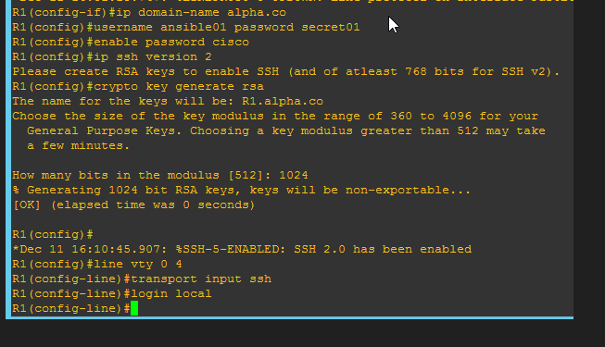

Figure 13 shows the creation of a hosts file in a Network Automation setup, which is crucial for initializing Ansible for network configuration management. This file includes the IP address and login credentials of a Cisco router, laying the groundwork for managing network devices via Ansible. For Alpha Consultants, this step is crucial as it supports their need to manage Cisco routers and switches efficiently, addressing requirements 4 and 4.2 of their case study. By compiling a comprehensive list of devices in the hosts file, Alpha ensures that Ansible can accurately and securely automate network tasks. Furthermore, this aligns with Requirement 6, which stipulates that the configuration management system be operated from a new server. This arrangement centralizes all network configurations and deployments, thereby boosting network reliability and management effectiveness for Alpha.

Figure 13 Creating a file called hosts for configuring Ansible

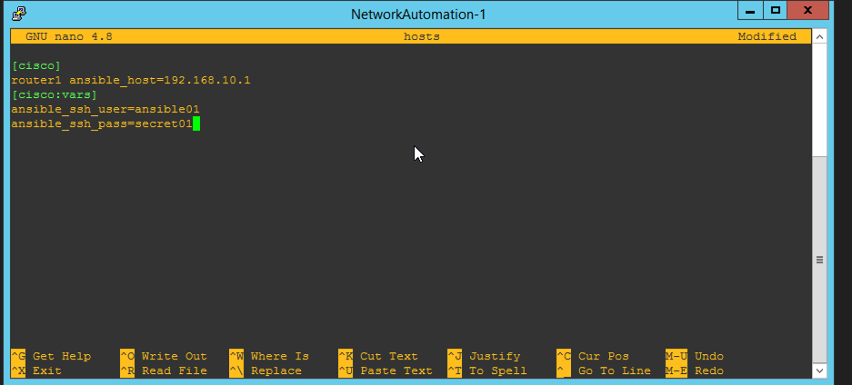

The image on Figure 14 shows creating and editing an ansible.cfg configuration file using the Nano text editor in the Network Automation environment. This file is essential for configuring Ansible's operational parameters, such as the inventory path, host key checking, command timeouts, and handling of deprecation warnings. **Requirement 6**, which mandates that the configuration management system must be hosted on a new server. By setting up this configuration file, Alpha is ensuring that Ansible operates with predefined settings that are optimal for their environment. This setup supports centralized management of network device configurations and server automation, enabling efficient deployment and management of the infrastructure.

Figure 14 creating ansible.cfg configuration file in nano text editor

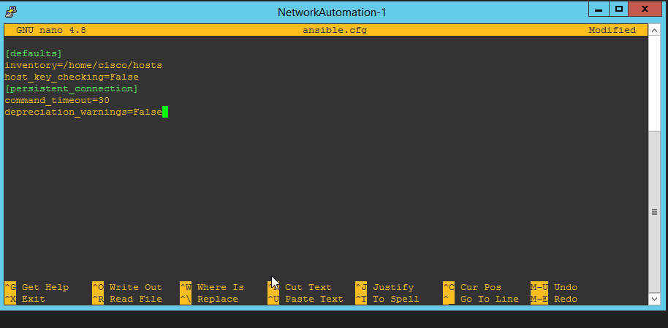

Figure 15 presents a configuration executed via an Ansible playbook in the Network Automation environment. The playbook, cisco.yml, is displayed in the nano text editor and is designed to disable HTTP services on network devices, thereby enhancing network traffic security. This objective is achieved through the "global config" task, which includes the command "no ip http servers" to effectively disable HTTP services on Cisco devices. This aligns with Alpha's goal of improving the security and reliability of their network infrastructure, as emphasized in their case study requirements (Requirement 4.2 and Requirement 4). By employing Ansible to automate this process, Alpha ensures strict adherence to security protocols across all network devices, contributing to a resilient and secure network environment.

Figure 15 Creating cisco.yml in nano text editor for configuration

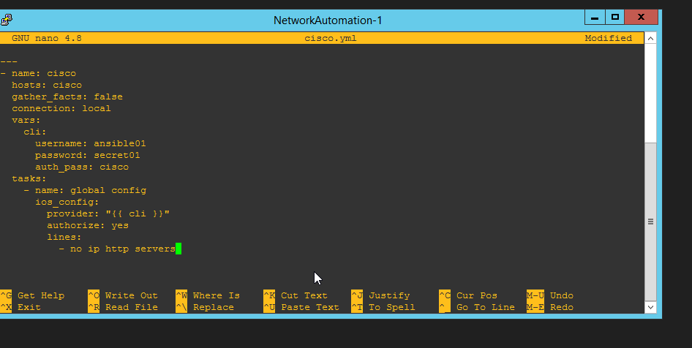

**Creating playbook on Ansible**

Figure 19 demonstrates the creation of an Ansible playbook file named cisco.yml, which is critical for the automated configuration of network devices. This playbook includes specific commands for configuring network settings such as enabling the HTTP server on a Cisco device. The screen shows the use of the Nano text editor within the Network Automation environment to edit and save the necessary commands and parameters. **Requirement 4 and 4.2** involves the configuration and management of network devices, such as Cisco routers and switches. By using Ansible to automate the disabling of HTTP services, Alpha enhances the security and efficiency of these devices. This automation ensures that configurations are standardized and applied uniformly, reducing the likelihood of security breaches and configuration errors.

Figure 19 shows Creating a file called cisco.yml is important before running the playbook

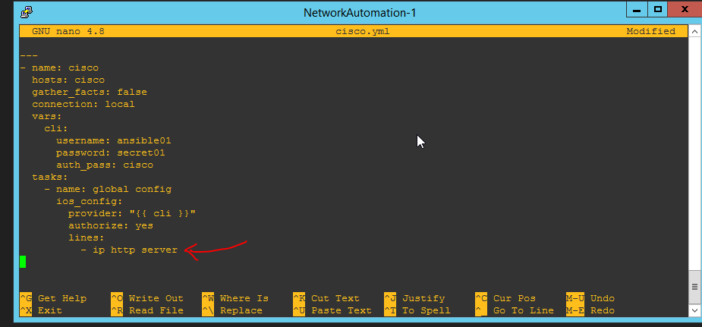

**Running the Ansible playbook**

Figure 17 showcases the execution of an Ansible playbook command, which is a crucial step in network configuration management. The screenshot displays the command ansible-playbook cisco.yml command and file being executed within the Network Automation environment, resulting in a successful configuration change with no tasks failing or unreachable. The ability to deploy configurations reliably across the network infrastructure is vital for ensuring that traffic is correctly routed to the designated servers and switches. The playbook in Figure 17 likely contains network configurations that help optimize traffic flow and improve load balancing, directly supporting Requirement 10.3 by enhancing the network’s capacity to handle service demands dynamically.

Figure 17 run the ansible playbook command

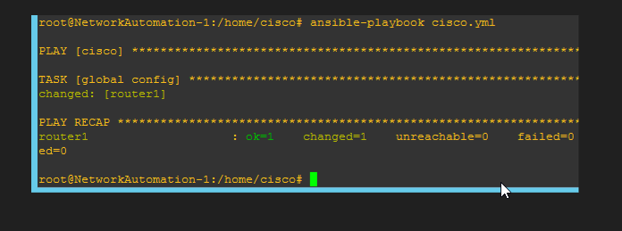

## Recommendations

 I recommend implementing Ansible for configuration of Cisco routers and other networking devices within Alpha's data center. This automation ensures (RAHMAN, 2019)consistency in device configurations, reduces human errors, and streamlines the deployment of network changes. (RAHMAN, 2019) Within Alpha to encourage the development of an in-house training sessions to network administrators would be helpful to enhance their proficiency in using Ansible, which will help in the quick adoption and troubleshooting of network automation. Additionally (Synaxa, 2024) Ansible's agentless architecture and use of YAML for playbook creation make it an ideal tool for scaling network operations without significant overhead. (Synaxa, 2024) This scalability ensures that Alpha can manage a growing number of devices as the company expands its services.

# SDN Network

## Introduction

As Alpha Consultants looks to modernize and expand its data center capabilities, the introduction of Software Defined Networking (SDN) through ONOS (Open Network Operating System) is a strategic move to address their current and future networking needs. Specifically, Alpha aims to use SDN to manage the network infrastructure of its new data center, which hosts various services including web hosting, Software as a Service (SaaS), Platform as a Service (PaaS), and cloud data storage. SDN, particularly through ONOS, will be employed to centrally manage and automate the data center’s network. This includes tasks such as load balancing traffic to servers, dynamically adjusting resources to meet demand, and ensuring efficient routing within the network. The adoption of SDN will provide Alpha with a more flexible and scalable network infrastructure compared to traditional static network setups.So I will be meeting the requirement of the case study by using the tool called ONOS

## Solutions

**Figure 1** of the SDN login screen can be seen as meeting the requirement to access and manage the software defined Network controller this access is essential for configuring and managing the SDN functionality as mentioned in requirement 9 where an SDN controller must be installed at the data center to manage the network

**Figure 1** SDN LOGIN Screen for for opening ONOS

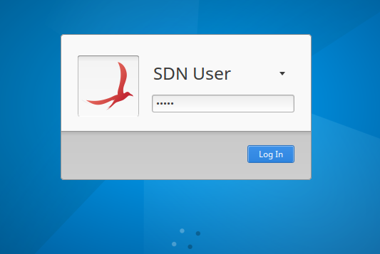

**Figure 1.1** of the image shows the terminal output startup of Onos because as for Alpha requirement 9 requires us to install the sdn controller to manager the network this process ensuring the network is controlled via centralized software defined approach and **Figure 1.2** displays the ONOS command line interface (CLI) following the successful startup and activation of essential network applications. this interface is critical as part of Requirement 9 of Alpha specifically calls for an SDN controller to be installed at the data center to effectively manage the network.

**Figure 1.1** ONOS Cluster Initialization

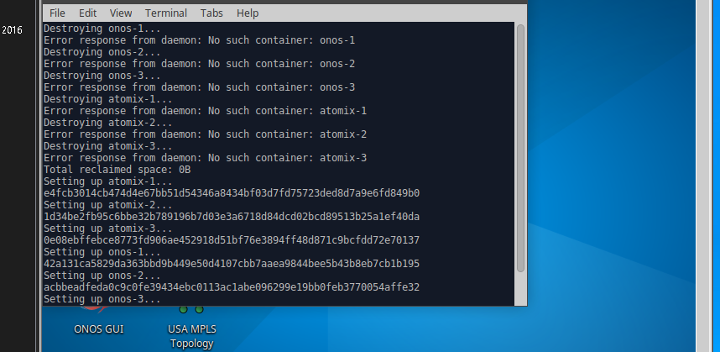

**Figure 1.2** ONOS Activation and Command Line Interface

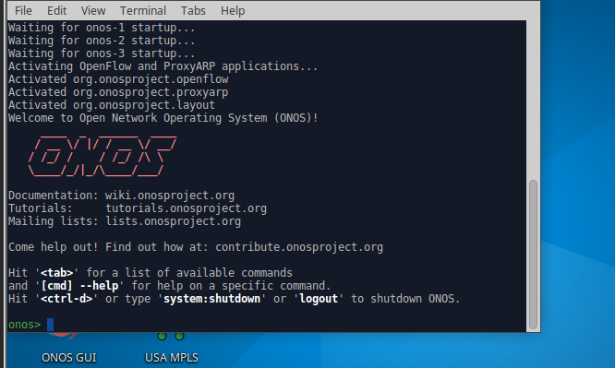

**Figure 2.3** displays the Mininet Command Line Interface output where a network simulation is being conducted. The output shows the initialization of a network topology involving multiple hosts (H1 to H45) and switches (S1 to S14), the starting of the network controller, and the execution of commands such as for the The "ping" command was used to test connectivity between hosts, specifically from host H11 to H41, which unfortunately shows 100% packet loss, indicating that the destination host is unreachable. So in relation to requirement 9 of the case study it is required to install sdn controller to manage the network effectively like the one shown in the screenshot

**Figure 2.3** Mininet command line interface for testing network

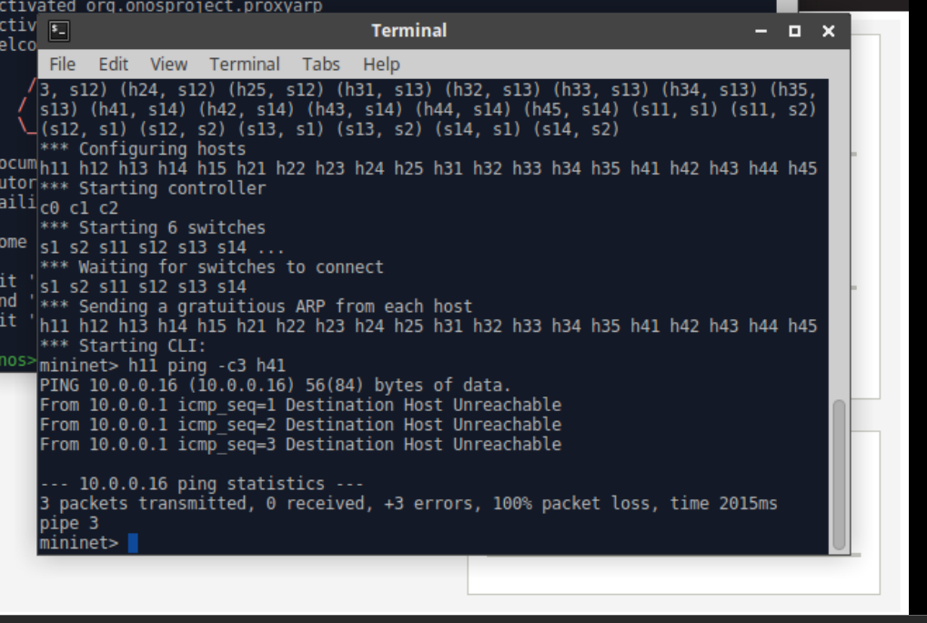

In these figures , the ONOS command line is employed to activate crucial network applications. Figure 2.4 illustrates the activation of the org.onosproject.fwd application, which is essential for implementing forwarding rules and enhancing routing intelligence. Figure 2.5then shows a successful ping test following this configuration, confirming that network connectivity has been effectively restored with typical ICMP response times.Both figures 2.4 and 2.5 effectively meets Requirement 9 of the Alpha case study. They demonstrate how the ONOS controller is used to activate vital network applications crucial for effective network management. Additionally, the successful ping test in Figure 2.4 verifies that the ONOS controller efficiently manages network connectivity issues. This ensures that the network is adeptly configured to support seamless communication between devices this is as a key factor in maintaining network reliability and performance, which is vital for the operational needs of Alpha Consultants.

The command apps -a -s provides detailed visibility and control over the applications running on the SDN controller, which is crucial for effective network management. This allows network administrators at Alpha to ensure all necessary network functionalities are operational, directly influencing the stability and efficiency of the network. As shown in in figure 2.3.1

Figure 2.3.1 command used in ONOS to display applications that are running

Figure 2.3.1 used this command to check and see which applications are running

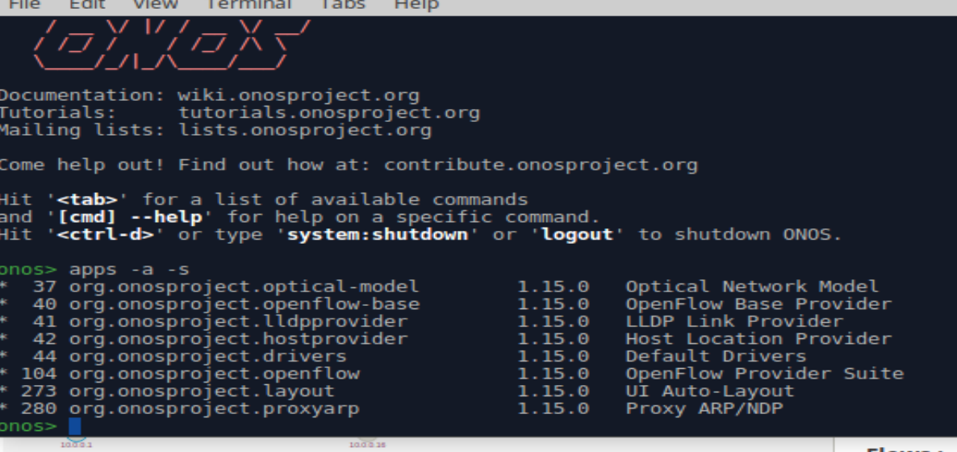

Figure 2.4 ONOS CLI - Application Activation

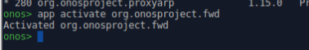

Figure 2.5 Successful Ping Network Test of the hosts

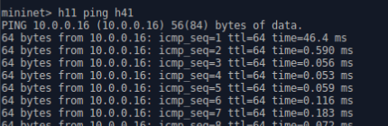

Figure 2.6 illustrates the use of the ONOS command line to add a host-to-host intent (add-host-intent), a crucial feature for configuring specific paths between two network hosts. This intent command is significant for its ability to outline detailed parameters such as selectors, which define the criteria for matching network traffic; treatments, which specify the actions to be taken on the traffic; and constraints, which impose conditions on how the paths should be managed. Although the command primarily sets up direct paths rather than implementing load balancing directly, it plays a vital role in the broader strategy of traffic management. By directing traffic through specified paths, this feature helps distribute the load more evenly across the network. This approach is particularly useful in managing network efficiency and can prevent any single server from being overwhelmed by traffic, indirectly supporting load balancing as required by Requirement 10.1 in the Alpha Consultants case study.

Figure 2.6 Used this command to add host to host in network

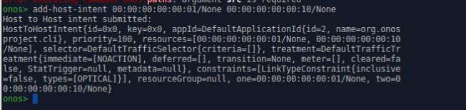

Figure 2.7 highlights the importance of verifying installed intents for dynamic network resource management at Alpha Consultants, directly supporting Requirement 10.2, which mandates adapting server availability based on demand. By ensuring that each intent, like the host-to-host connections, is actively functioning, Alpha can adjust its network infrastructure in response to real-time needs. This capability enables them to modify network paths flexibly, ensuring that resources are efficiently distributed as network demand fluctuates. This approach ensures that Alpha's network remains responsive and efficient, adapting seamlessly to varying loads.

Figure 2.7 Verification of Installed Host-to-Host Intent in ONOS

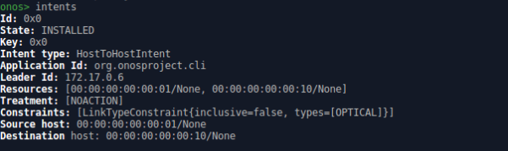

In Figure 2.8 we see the use of the ONOS “flows- s” command output which is integral part for managing network flow within a software-defined network environment this command displays detailed data on various flows entries set up across network. This covers all the requirement of the case study This demonstrates by the flows -s command cover all the critical aspects required by Alpha Consultants as laid out in their case study, specifically addressing Requirement 10, which involves ensuring robust network management.

Figure 2.8 using this command to check flow entries of the network

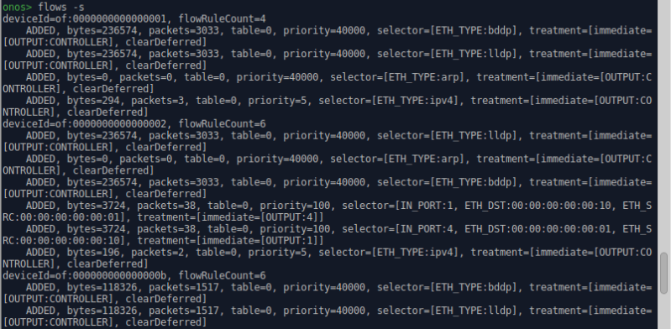

Figure 2.9 displays a session within the Mininet terminal, illustrating how network administrators can manually control and test network components by toggling the connectivity of network links. These commands are used to simulate and observe how the network behaves under conditions of partial failure and subsequent recovery, which is crucial for testing the resilience and configuration of network systems. The specific requirements of 10.1, 10.2, and 10.3 are addressed through this testing, ensuring that the network can maintain performance and reliability in the face of link failures, thus aligning with Alpha's strategic objectives.

Figure 2.9 Testing by using this command to test and change the connectivity for the network system.

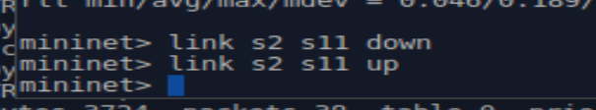

## Recommendations

Implementing Software-Defined Networking (SDN) in Alpha Consultants' data center can significantly enhance the management and performance of high-traffic web hosting and other services. SDN offers centralized control, flexibility, and scalability. (Open Networking Foundation, n.d.)For instance, ONOS, an open-source SDN controller, supports dynamic resource management, allowing for efficient handling of varying traffic loads. (Open Networking Foundation, n.d.) Another benefit would be SDN can intelligently manage network traffic, ensuring even distribution across servers. (CERN ,2016)This improves website uptime and responsiveness, which is crucial for customer satisfaction and retention, especially for high-traffic sites. ONOS supports dynamic load balancing, optimizing resource utilization and enhancing service quality. (CERN, 2016) Additionally ONOS provides a centralized control interface that simplifies network administration, allowing for quick adaptations to new customer requirements without significant infrastructure changes. This approach aligns with the need for cost-effective solutions in modern data centers for Alpha.

References

<https://www.apnic.net/about-apnic/corporate-documents/documents/resource-guidelines/reverse-zones/>

<https://www.isc.org/docs/ReverseDNSpresentation.pdf>

www.linkedin.com. (n.d.). *What are the most common DNS server configuration mistakes?* [online] Available at: <https://www.linkedin.com/advice/1/what-most-common-dns-server-configuration-sbh1c>.

Open Networking Foundation. (n.d.). *Open Network Operating System (ONOS) SDN Controller for SDN/NFV Solutions*. [online] Available at: <https://opennetworking.org/onos/>.

CERN (2016). *ATL-DAQ-SLIDE-2016-759*. Available at: <https://cds.cern.ch/record/2221659/files/ATL-DAQ-SLIDE-2016-759.pdf>

RAHMAN, I. (2019). *Ansible for Beginners: Manage cisco router with ansible playbook*. [online] IMTIAZ RAHMAN. Available at: <https://imtiazrahman.com/2019/05/19/ansible-for-beginners-manage-cisco-router-with-ansible-playbook/>

Synaxa. (2024). *Using Ansible For Network Automation – Synaxa*. [online] Available at: <https://synaxa.io/using-ansible-for-network-automation/>

Kumari, P. (2022). *What are the Benefits of Using Docker Containers & When Should They Be Used?* [online] Hackernoon.com. Available at: <https://hackernoon.com/what-are-the-benefits-of-using-docker-container-and-when-should-they-be-used>.

Further reading and source material

www.gspann.com. (n.d.). *Comparing Configuration Management Tools: Chef vs. Puppet vs. Ansible*. [online] Available at: <https://www.gspann.com/resources/blogs/puppet-vs-chef-vs-ansible/>.

‌

‌

‌

‌

‌

‌